# Portal Modifications – Assessments

## Apr 11th 2019

* The Assessments App is available to:
  + Managers
  + Administrators
* Test signing into Portal with your appropriate credentials
* When in Assessments, enter a known Learner Id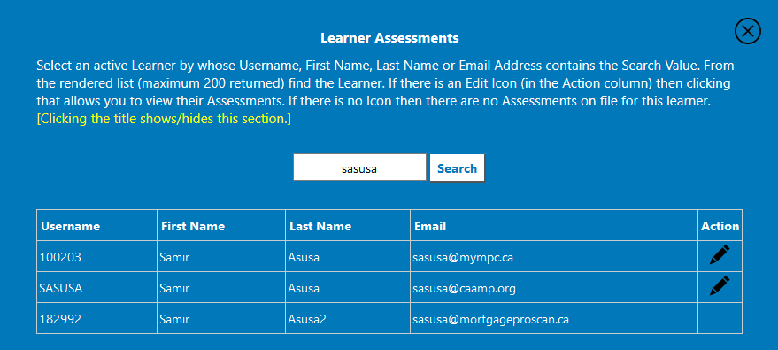
* Select the first row and it will pull up all Assessments for Samir Asusa

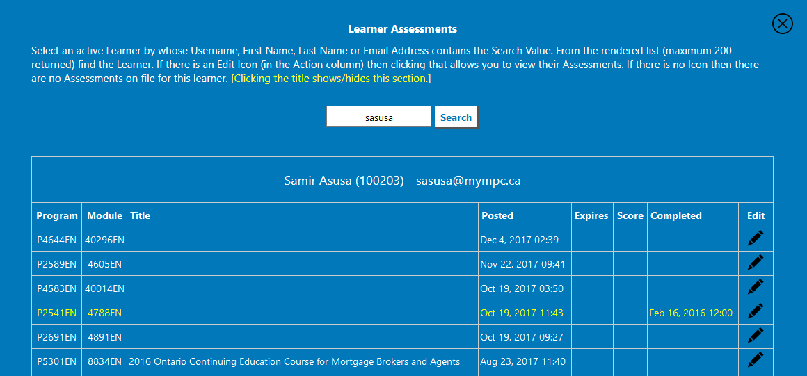

* Click on the first Completed Assessment and you’ll see Brian’s RTE Session Status Panel appear:

